GIT DOWNLOAD LINK: https://git-scm.com/downloads

GIT Bash:
Bash, Terminal, Bash Shell, Shell Scripting.

Difference Between Kernal and Shell.
- Kernal ?
- Its a core of operating system that controls all the tasks of the system.
- Shell ?
- Its an interface that allows to communicate with the kernal.

What is Bash shell ?
- Give NUT SHELL Example.

COMMENTS:
All indigenous GIT command is prefixed "git"

Folders: Blue color; Files: White color
git version: to know the version of git
pwd(Print working directory): to know the directory of git
c: Change directory
/: Folder
cd /d : To set new directory
ls: list the items of the folder
clear: to clear previous commands
ls -a: Shows all hidden files
cd .. : Back one folder (Double DOT represent Parent directory)(Single DOT represent Present directory)
cd ../.. Back two folders
which : helps to know the place of the system executable files(EG: which clear)

HOW TO OPEN ANY FILE ?

mkdir folder name : Create Folder
rmdir folder name : remove folder (Empty Directory)
rm -r folder name: remove folder even if a file is present
echo hello >> filename.txt: to put connect in a text file
touch filename.txt: Create file
rm -rf filename.txt: Remove file
cat filename.txt : Print the data of the file

THERE ARE 3 AREAS IN GIT:
1. Working directory<<ADD>> 2.Staging area<<COMMIT>>3.Repository

echo "hello World">> filename.txt

CONFIGURE GIT OR DEFINE OURSELVES:
git config --global user.name "David"
git config --global user.email "davidselvan11@gmail.com"

DELETE IDENTITY COMMAND:
git config --global --unset user.name
git config --global --unset user.email

MY GLOBAL CONGIGURATION:
git config --global -l

TO CHECK ALL CONFIGURATION:
git config -l

TO INITIATE GIT(Repository): This creates git which is hidden by defauts.
git init

TO KNOW STATUS: Repository status.
git status

WORKING DIRECTORY TO STAGING AREA:First time will give warning.
git add file.txt / git add . this will add all files of the folder.
CHECK STATUS AGAIN: Status would've changed now
git status

TO ADD ANY PARTICULAR FORMAT:
git add *.txt OR git add *.doc

TO REVERSE ADD:
git rm --cached filename.txt

TO MAKE CHANGES TO FILES IN STAGING AREA:
vi filename.txt
i
enter required data
esc
:wq

TO KNOW WHAT CHANGES HAPPENDED:
git diff

TO CHECK LOGS: Ensuring status of COMMIT
git log

TO CHECK LOGS IN SINGLE LINE:
git log --oneline

TO COMMIT ALL FILES IN STAGING AREA:
git commit -m "initial commit" Initial commit is the message we want to pass. EG: Like hint for what changes made.

TO COMMIT SPECIFIC FILES IN STAGING AREA:
git commit filename.txt -m "Message"

CHECK STATUS NOW: It will be different now(Working tree clean)
git status
ENSURE STATUS:
git log

HELP:
git help OR git help remote

TO IGNORE SOME FILES: Video time: 19.39 cheeta
touch .gitignore
vi .gitignore
type the file that needs to be ignored

TO IGNORE A FOLDER
demofile/

HARD RESET : Video time 30.45 cheeeta
git reset --hard code

BRANCH:
TO VIEW ALL BRANCHES:
git branch

TO CREATE NEW BRANCH
git branch MASTERD

TO DELETE BRANCH:
git branch -d branchname

TO GET INTO NEW BRANCH
git checkout branchname

TO CREATE NEW BRACH AND GET INTO IT:
git checkout -b MASTERC

TO MERGE MASTER AND MASTERC: do this from master
git merge masterc

UNDO IN STAGING AREA:
COMMAND TO GO BACK ONE TEST BACK
git checkout .

UNDO AFTER COMMITED:
COMMAND TO GO BACK FROM LAST CHANGE: Copy the code of the commit you want to go back
git checkout code

TO BACK TO PREVIOUS:
git checkout Master

CREATING REMOTE REPOSITORY:
1.Create New repository in github.
Now have to name the URL.

CHECK REMOTE STATUS:
git remote

TO REMOVE REMOTE:
git remote remove urlname

NAMING URL:
git remote add orgin URL

CHECK REMOTE STATUS:
git remote

MATER TO MAIN:
git branch -M main

COMMAND TO PUSH LOCAL TO CLOUD:
git push -u orgin main

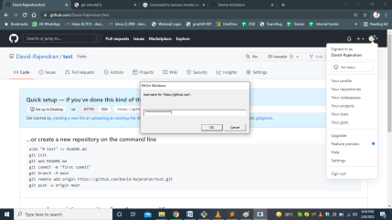

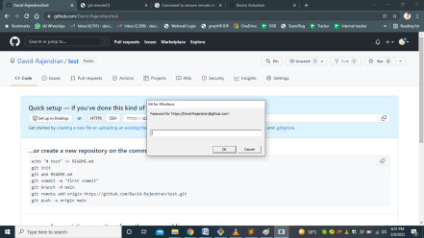
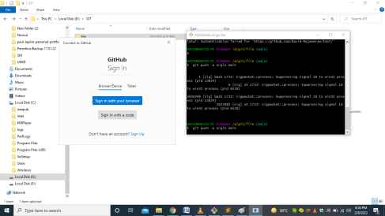
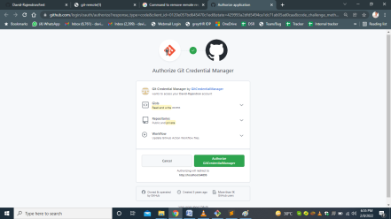
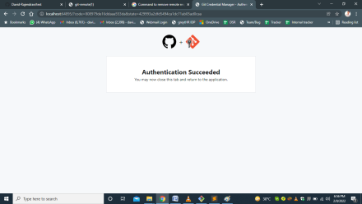

CHECK STATUS ONCE: will get this "Your branch is up to date with 'orgin/main'"
git status

*RELODE CLOUD PAGE
*Then CREATE ONE NEW FILE

CHECK STATUS: it will remain the same.
git status

PULL COMMAND: dummy file will get reflected
git pull orgin

*reload local location and get the file here.

WAYS TO DO:
1.New Project(Right click, select->Get Bash here)
2. Adding git to existing project
3.Cloning Someone else project(COMMAND: git clone URL)

